Steps, Inputs, Outputs, and Screenshots - Bug Data

In the game, it shows the words and score.  The test result shows that user B (Computer) has a higher score than user A (Me) and the reason is user B has more clear words as it shows in screenshots.

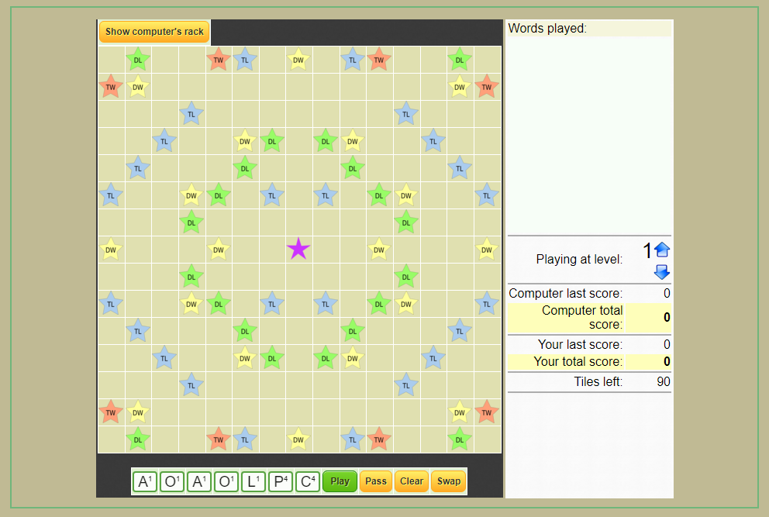

 Both users are ready to start and there is no score.

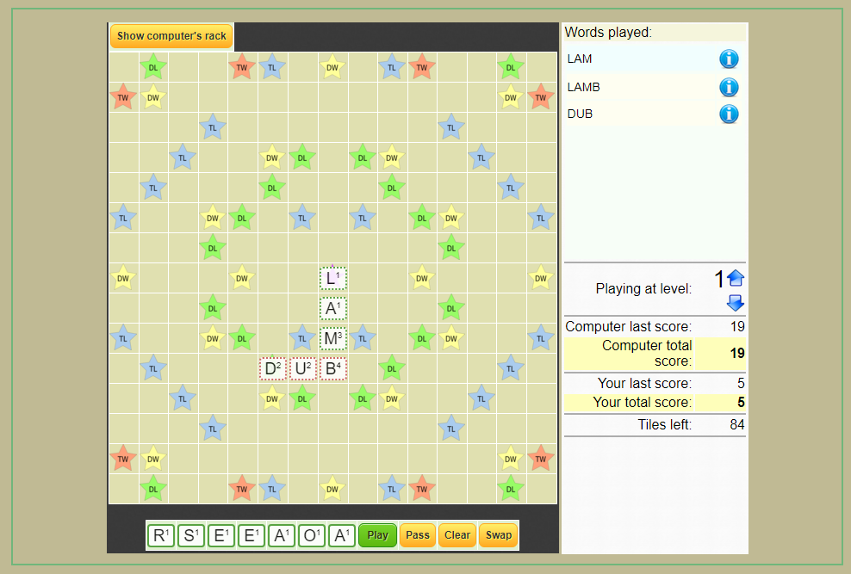

After user A started to play and then user B.  They both have their scores.  User B has a score of 19 and user A has a score of 5 based on clear words.

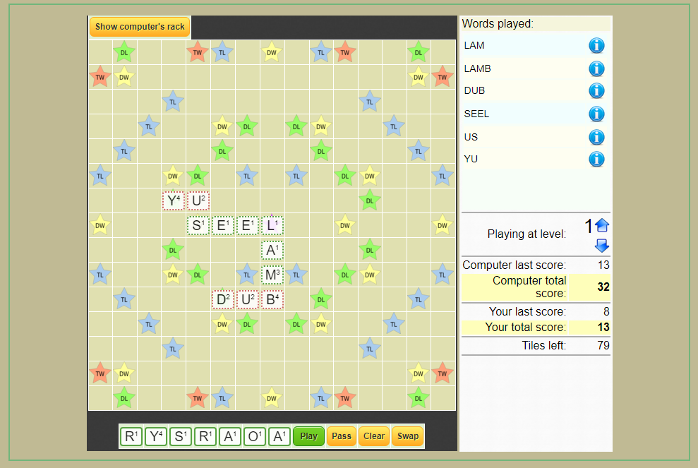

Finally, user B has a score of 13 that gives a total of 32 points.  User A has a score of 8 that gives a total of 13 points.  Based on the result and case test, User B is the winner as expected.